

TEEGALA KRISHNA REDDY ENGINEERING COLLEGE
(UGC-Autonomous)
Approved by AICTE, Affiliated by JNTUH, Accredited by NAAC- ‘A’ Grade Medbowli, Meerpet, Balapur, Hyderabad, Telangana- 500097
Mob: 9393959597 Email: info@tkrec.ac.in, deanacademics@tkrec.ac.in
DEPARTMENT OF ELECTRONICS AND COMMUNICATION ENGINEERING

MINI PROJECT ABSTRACT

Project Title: DESIGN AND IMPLEMENTATION OF ENCODERS AND DECODERS WITH CMOS TECHNOLOGY |  |  |  | Batch No: 03
Candidate Details
S.No | Register No | Candidates Name | Mobile Number | Email ID
1 | 22R91A04D7 | Kuppireddy Sai Karthik Reddy | 8790662692 | 22r91a04d7@tkrec.ac.in
2 | 22R91A04H6 | Nomula Saikiran | 8247219818 | 22r91a04h6@tkrec.ac.in
3 | 22R91A04G7 | Mothe Pravalika | 8897339064 | 22r91a04g1@tkrec.ac.in
4 | 22R91A04E7 | Markanti Chandramohan Reddy | 9182017541 | 22r91a04e8@tkrec.ac.in

Guide Details
Name | Mr M.V.V.SATYA NARAYANA CHOWDARY | Designation | Assistant Professor
Objective:
The objective of a voice-controlled car using Arduino project is to design and implement a system that allows a car to be controlled through voice commands. Here are the main goals:
- Microcontroller Integration: Use an Arduino microcontroller to process voice commands and control the car's movements.
- Motor Control: Design a motor driver circuit to interface the Arduino with the car's motors, enabling precise movement.
- User-Friendly Interface: Create a simple and intuitive user interface for seamless operation.
The project typically involves components like an Arduino Uno, a voice recognition module, a motor driver (e.g., L298N), DC motors, a Bluetooth module (e.g., HC-05), and a power supply.

Abstract:
This project focuses on developing a voice-controlled car using an Arduino microcontroller. The primary objective is to enable the car to respond to voice commands, offering a hands-free control solution. The project employs a voice recognition module to interpret user commands, which are then processed by the Arduino. The microcontroller subsequently directs the motor driver circuit to control the car's movements.
Key components include an Arduino Uno, a voice recognition module, a motor driver (L298N), DC motors, a Bluetooth module (HC-05), and a power supply. The design emphasizes simplicity and user-friendliness, aiming to create an intuitive interface for seamless operation.
Overall, the project demonstrates the integration of voice recognition technology with microcontroller-based systems to achieve innovative and practical applications in robotics.

Index Terms— Voice-controlled car, Arduino, Voice recognition, Microcontroller, Motor driver, Bluetooth module, Robotics, Hands-free control, User-friendly interface.

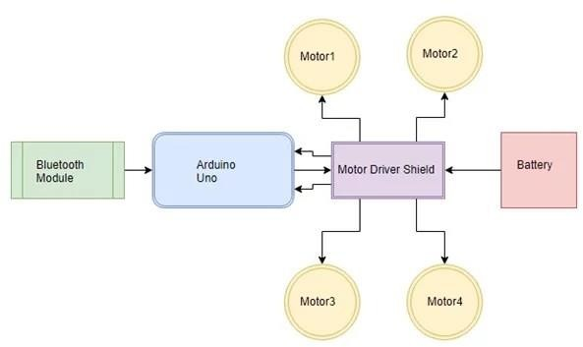
Block Diagram:

Fig : Block Diagram of Voice Controlled Car using Arduino

Advantages:

- Hands-Free Control
- Safety
- Accessibility
- Educational Value
- Innovation
- Customization.

Applications:

- Assisted Living
- Home Automation
- Educational Tool
- Entertainment
- Security Patrol
- Delivery Services
- Research and Development
- Marketing Demonstrations
- Elderly Assistance.

Signature of the guide

